**PROGRAM :**

void setup()

{

Serial.begin(9600);

pinMode(12,OUTPUT);

pinMode(13,INPUT);

}

void loop()

{

int motion=digitalRead(13);

Serial.print("Position is :");

Serial.println(motion);

double data= analogRead(A2);

double n=data/1024; double v=n*5;

double off=v-0.5;

double temp=off*100;

Serial.print("Temparture data :");

Serial.println(temp);

if(temp>60){ tone(12,1000,1000);}

if(motion==1){ tone(12,2000,1000);}

}

1. Circuit Connection and Output:

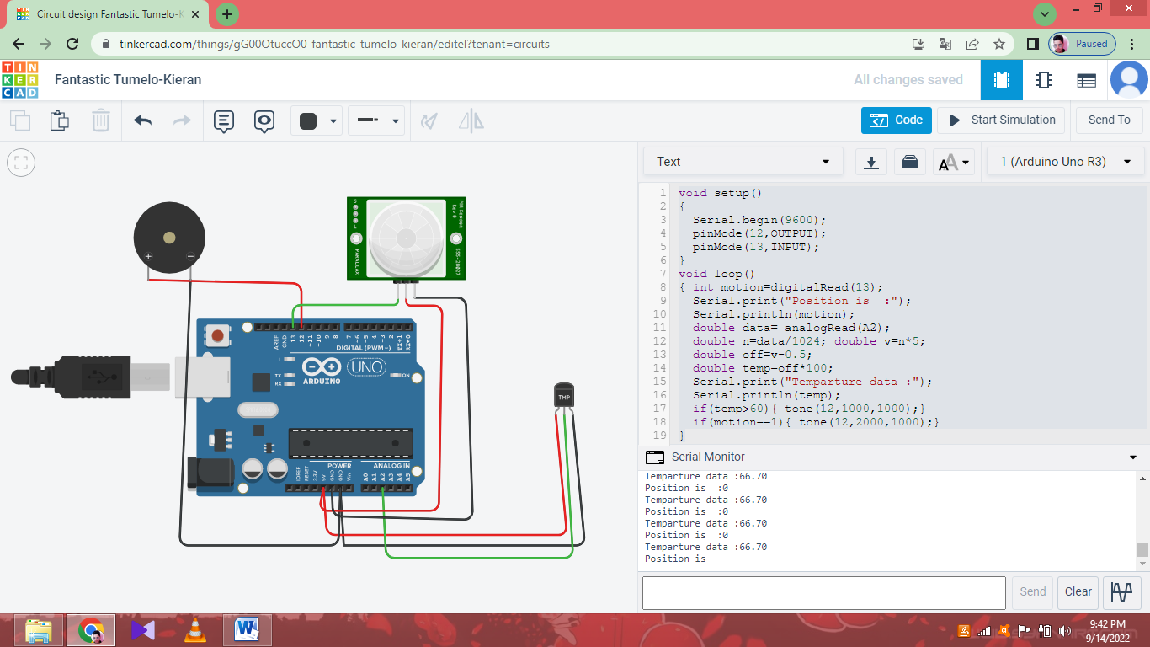

1. Alar m sounds when Temperature is greater than 60.

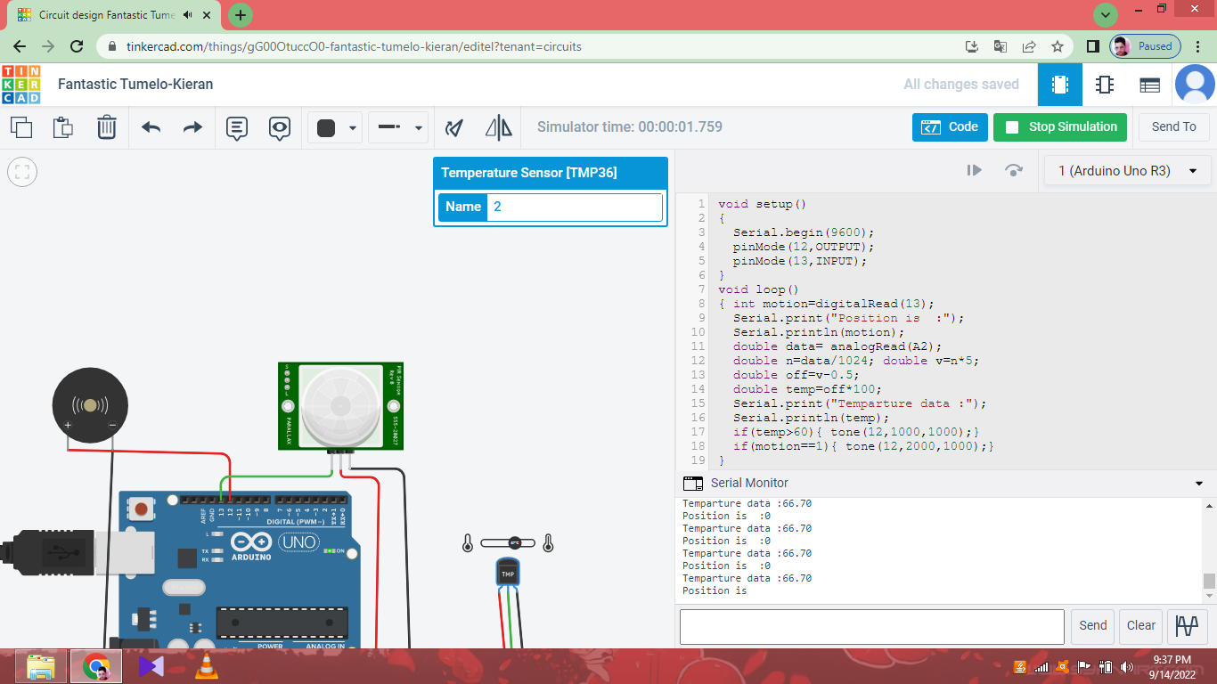

1. Alar m sounds when Motion is detected.

